* As database servers are protected by Firewall on server we won’t be able to access the database Query Editor in the database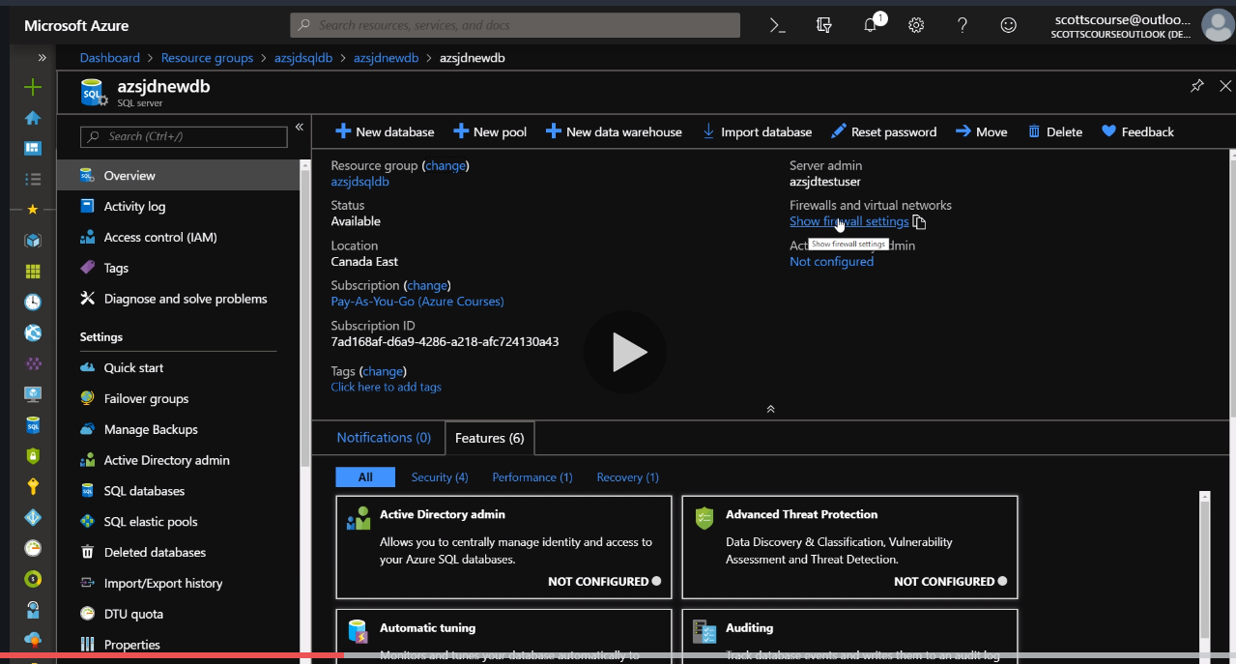
* We need to add client IP to whitelist our portal network to access the database through server. 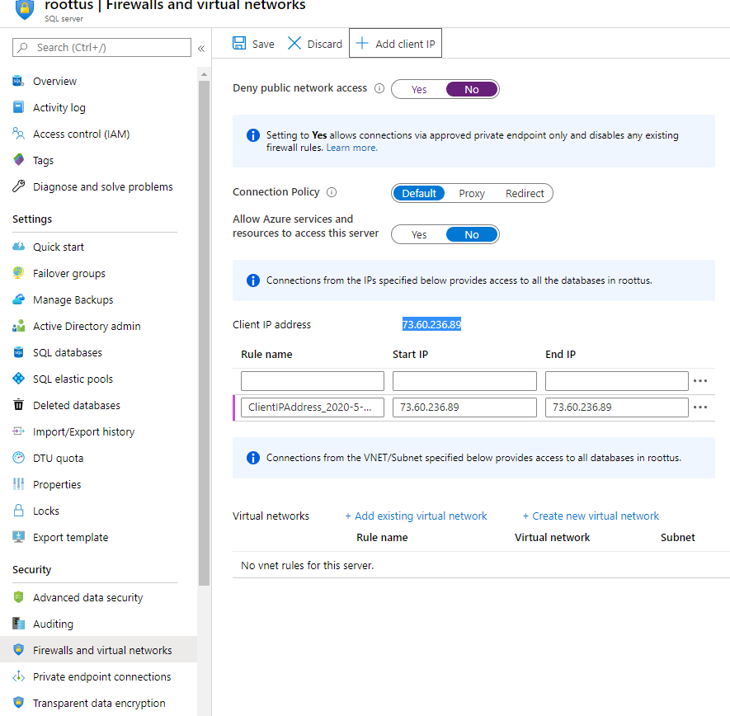
* We can also connect it to active directory admin directly for doing reads and write. 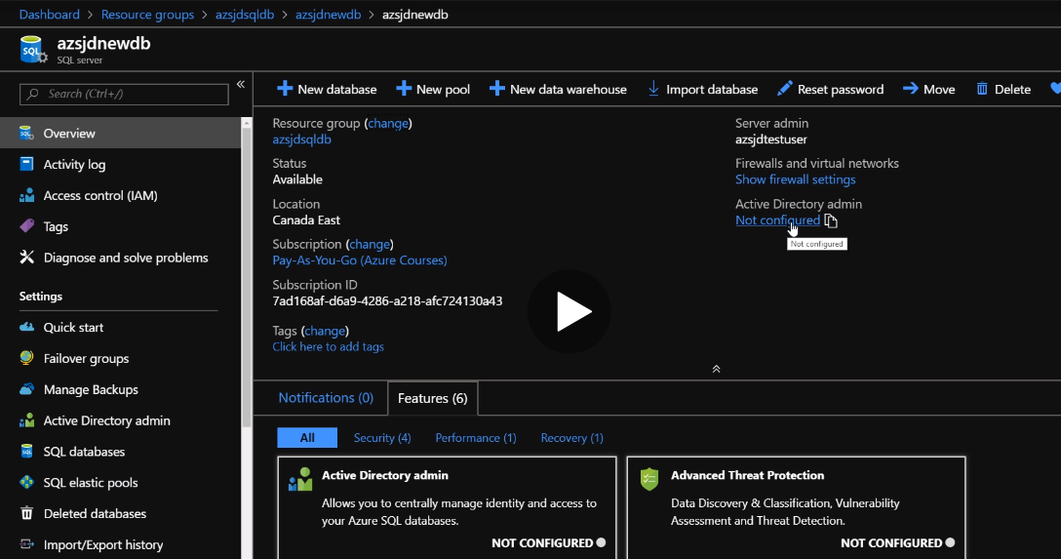

After this we will be able to access the query editor in the database for insights of it.